Kubernetes-03
- Create a ClusterIP service for an Apache web server pod.

Step 1. Create an Apache Pod
Create a YAML file:
vi apache-pod.yaml and add the script.

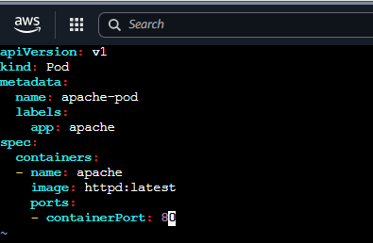
Save and exit.

Step 2. Create the Pod
kubectl apply -f apache-pod.yaml
You should see:
pod/apache-pod created

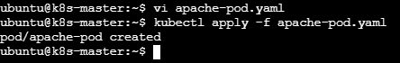

Step 3. Verify the Pod
kubectl get pods
You should see something similar to:
NAME READY STATUS RESTARTS AGE
apache-pod 1/1 Running 0 10s
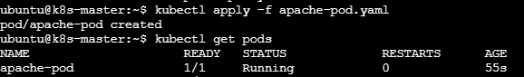
Also verify the label:
kubectl get pod apache-pod --show-labels
You should see:
app=apache

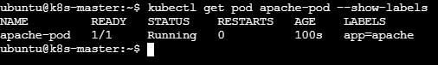

Step 4. Create the ClusterIP Service
Create another YAML file:
vi apache-service.yaml and add the script

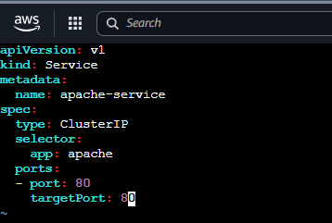
Save and exit.

Step 5. Create the Service
kubectl apply -f apache-service.yaml
Expected:
service/apache-service created

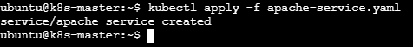

Step 6. Verify the Service
kubectl get svc
You should see something like:
NAME TYPE CLUSTER-IP EXTERNAL-IP PORT(S)
apache-service ClusterIP 10.96.xxx.xxx <none> 80/TCP

The important part is:
TYPE = ClusterIP
and:
PORT = 80

Step 7. Check the Service Endpoints
This is an important verification step:
kubectl get endpoints apache-service
You should get something similar to:
NAME ENDPOINTS
apache-service 10.244.x.x:80
This confirms that the Service has found the Apache Pod.
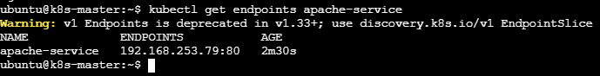

Step 8. Test the Apache Service from inside the cluster
Because ClusterIP is accessible only inside the Kubernetes cluster, create a temporary testing pod:
kubectl run test-pod --image=curlimages/curl -it --rm -- sh
Inside the test pod, run:
curl http://apache-service
You should receive Apache's HTML response, something similar to:
<html><body><h1>It works!</h1></body></html>
You can also test using the full Kubernetes DNS name:
curl http://apache-service.default.svc.cluster.local
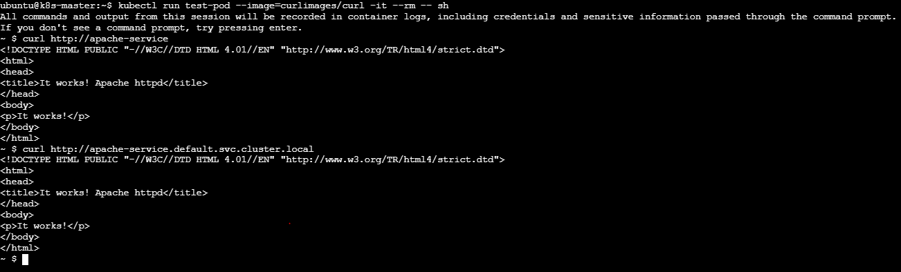
2. Expose an Nginx pod externally using a NodePort service.

1. Create the Nginx Pod
Run on your k8s-master:
kubectl run nginx --image=nginx

Check it:
kubectl get pod nginx -o wide
Wait until you see:
nginx 1/1 Running

2. Create a NodePort Service
Run:
kubectl expose pod nginx --name=nginx-nodeport --port=80 --target-port=80 --type=NodePort

What this does
- nginx → exposes the Nginx Pod
- --port=80 → Service port
- --target-port=80 → Nginx container port
- --type=NodePort → makes the Service accessible through a port on each Kubernetes node

3. Check the Service
kubectl get svc nginx-nodeport
You should see something like:
NAME TYPE CLUSTER-IP EXTERNAL-IP PORT(S)
nginx-nodeport NodePort 10.96.x.x <none> 80:30xxx/TCP
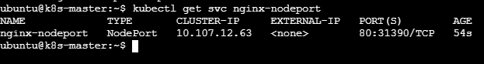

80:31390/TCP
Here:
80 = Service port
31390 = NodePort
The NodePort is normally in the range 30000–32767.

4. Get the Node IPs
Run:
kubectl get nodes -o wide
Your nodes are currently:
k8s-master 172.31.74.66
ip-172-31-71-65 172.31.71.65
ip-172-31-79-160 172.31.79.160
For external access from your laptop/browser, you need the public IP of one of these EC2 instances.
In AWS EC2, check the Public IPv4 address of the node.

5. Test the NodePort
Service shows:
80:31390/TCP
Then the URL is:
http://<NODE-PUBLIC-IP>:30080
For example:
http://13.234.XX.XX:30080
You should see the Welcome to nginx! page.
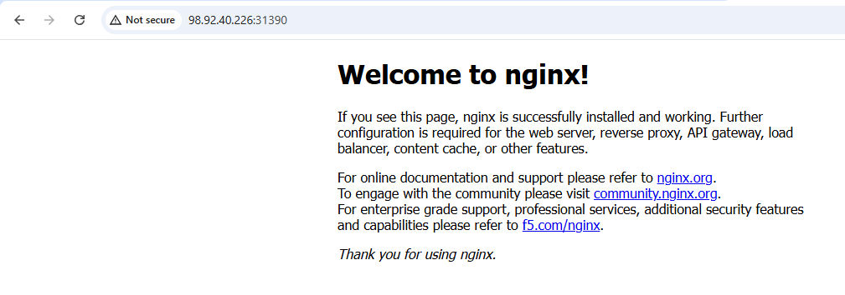

3. Deploy a Replication Controller to maintain 3 replicas of an Nginx pod.

1. Create the ReplicationController YAML
On k8s-master, create a file:
vi nginx-rc.yaml and add
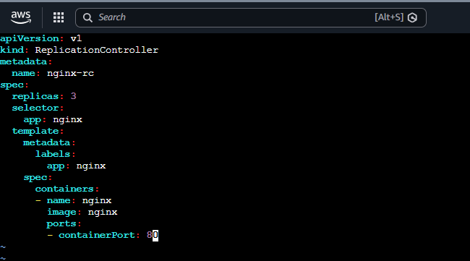
Save and exit.

2. Create the ReplicationController
kubectl apply -f nginx-rc.yaml
You should see:
replicationcontroller/nginx-rc created
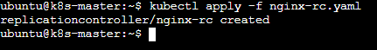

3. Check the ReplicationController
kubectl get replicationcontroller
or:
kubectl get rc
Expected:
NAME DESIRED CURRENT READY AGE
nginx-rc 3 3 3 ...
This means Kubernetes is maintaining 3 replicas.
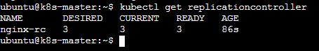

4. Check the Pods
kubectl get pods -o wide
You should see three Nginx Pods, for example:
nginx-rc-xxxxx 1/1 Running
nginx-rc-yyyyy 1/1 Running
nginx-rc-zzzzz 1/1 Running
The exact Pod names will be different in your cluster.
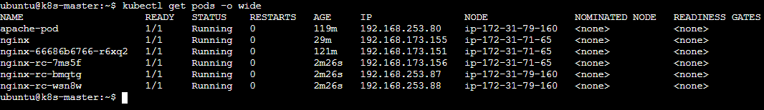

5. Verify self-healing
This is an important part of a ReplicationController.
First check:
kubectl get pods
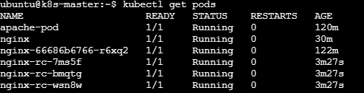
Pick one of the Nginx Pods and delete it:
kubectl delete pod nginx-rc-wsn8w
Immediately check:
kubectl get pods
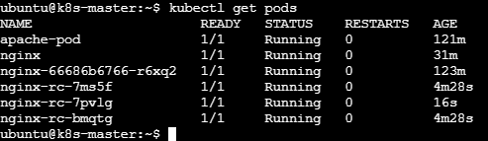
Kubernetes creates a new Nginx Pod nginx-rc-bmqtg automatically.
Check kubectl get pods –w
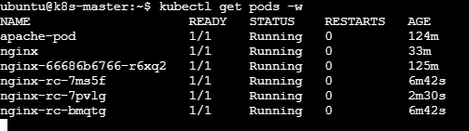
The number of Pods should remain at 3.
So the main requirement is:
Replication Controller continuously maintains 3 running Nginx Pod replicas.
4. Scale the ReplicationController from 3 replicas to 5 replicas.

Step 1. Scale the ReplicationController
Run:
kubectl scale rc nginx-rc --replicas=5
Expected output:
replicationcontroller/nginx-rc scaled

Step 2. Verify the ReplicationController
kubectl get rc nginx-rc
You should see:
NAME DESIRED CURRENT READY
nginx-rc 5 5 5
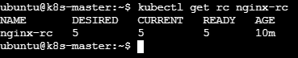

3. Verify the Pods
kubectl get pods -l app=nginx
You should now have 5 Nginx Pods:
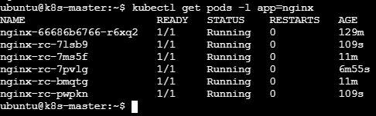

Step 4. Watch the scaling happen
kubectl get pods -l app=nginx -w
Kubernetes will create 2 additional Pods, changing:
3 replicas → 5 replicas
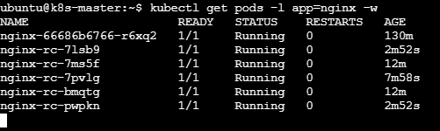
5. Create a ReplicaSet to manage pods based on multiple labels (prod and test).

Step 1. Create the ReplicaSet YAML
Run:
vi nginx-rs.yaml and add

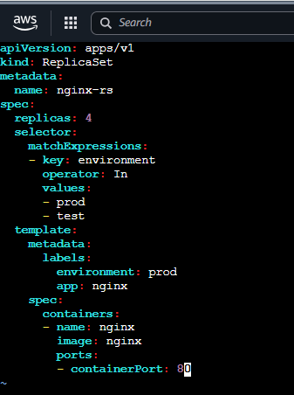
Save and exit.

Step 2. Create the ReplicaSet
kubectl apply -f nginx-rs.yaml
Expected:
replicaset.apps/nginx-rs created

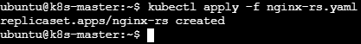

Step 3. Verify the ReplicaSet
kubectl get rs
You should see:
NAME DESIRED CURRENT READY
nginx-rs 4 4 4
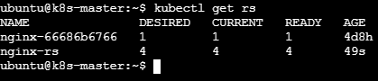

Step 4. Check the Pods and labels
kubectl get pods --show-labels
You should see 4 Nginx Pods with:
environment=prod
app=nginx
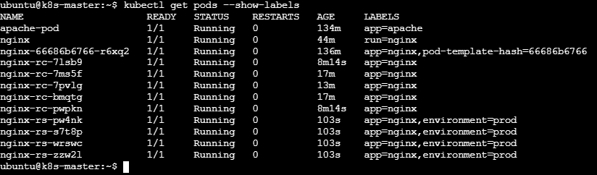

Step 5. Test the prod label
kubectl get pods -l environment=prod
This should show the Pods because prod is one of the values accepted by the ReplicaSet selector.

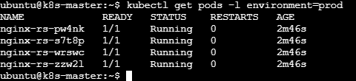

Step 6. Test the test label
kubectl get pods -l environment=test
Initially, this may show no Pods, because our Pod template creates Pods with:
environment: prod
The ReplicaSet selector:
operator: In
values:
- prod
- test
means:
"Manage Pods whose environment label is either prod OR test."
6. Deploy a ReplicaSet that excludes pods with the label backend.

Step 1. Create the ReplicaSet YAML
vi nginx-rs-exclude-backend.yaml and add

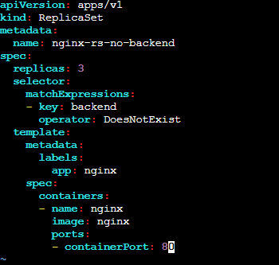

Save and exit.

Step 2. Create the ReplicaSet
kubectl apply -f nginx-rs-exclude-backend.yaml
Expected:
replicaset.apps/nginx-rs-no-backend created

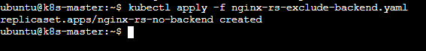

Step 3. Verify the ReplicaSet
kubectl get rs
You should see:
NAME DESIRED CURRENT READY
nginx-rs-no-backend 3 3 3

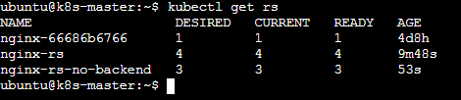

Step 4. Check the Pods
kubectl get pods --show-labels
The three new Pods should have:
app=nginx
and should not have:
backend

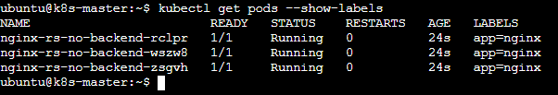

What DoesNotExist means
This part:
matchExpressions:
- key: backend
operator: DoesNotExist
means:
Select/manage Pods where the backend label does not exist.

Step 5.Verify the exclusion
Create a test Pod with the backend label:
kubectl run backend-test --image=nginx --labels="backend=true"

Check:
kubectl get pods --show-labels
You should see backend-test, but the ReplicaSet should not manage it.
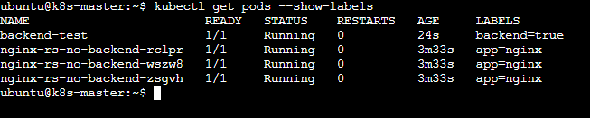
Check the ReplicaSet:
kubectl get rs nginx-rs-no-backend
It should still maintain exactly 3 replicas.
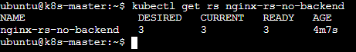
7. Test load balancing across multiple pods using a NodePort service.

Step 1: Check your existing Pods
You already have 3 Pods from the ReplicaSet:
kubectl get pods -o wide
You should see:
nginx-rs-no-backend-xxxxx
nginx-rs-no-backend-yyyyy
nginx-rs-no-backend-zzzzz
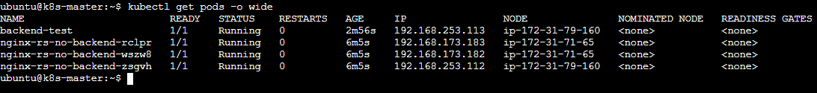

Step 2: Create a NodePort Service
Create the YAML file:
vi nginx-nodeport.yaml and add

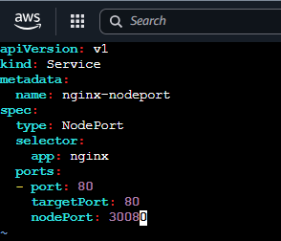

Save and exit.

Now apply it.

Step 3: Verify the Service
kubectl get svc nginx-nodeport
Expected:
NAME TYPE CLUSTER-IP EXTERNAL-IP PORT(S)
nginx-nodeport NodePort 10.96.x.x <none> 80:30080/TCP

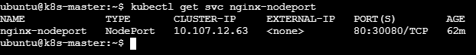
Here:
- 80 = Service port
- 30080 = NodePort
- targetPort 80 = Nginx container port

Step 4: Check which Pods are behind the Service
Run:
kubectl get endpoints nginx-nodeport
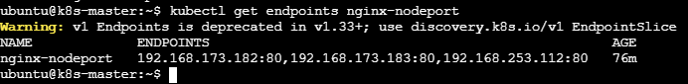
You should see the IP addresses of your 3 Nginx Pods:
nginx-nodeport 192.168.x.x:80,192.168.x.x:80,192.168.x.x:80
This confirms that the Service is connected to multiple Pods.
You can also verify with:
kubectl get pods -l app=nginx -o wide

Step 5: Test the NodePort
First get your worker node IPs:
kubectl get nodes -o wide

NAME INTERNAL-IP
k8s-master 172.31.74.66
ip-172-31-71-65 172.31.71.65
ip-172-31-79-160 172.31.79.160

From a machine that can reach the nodes, test:
curl http://172.31.71.65:30080
or:
curl http://172.31.79.160:30080

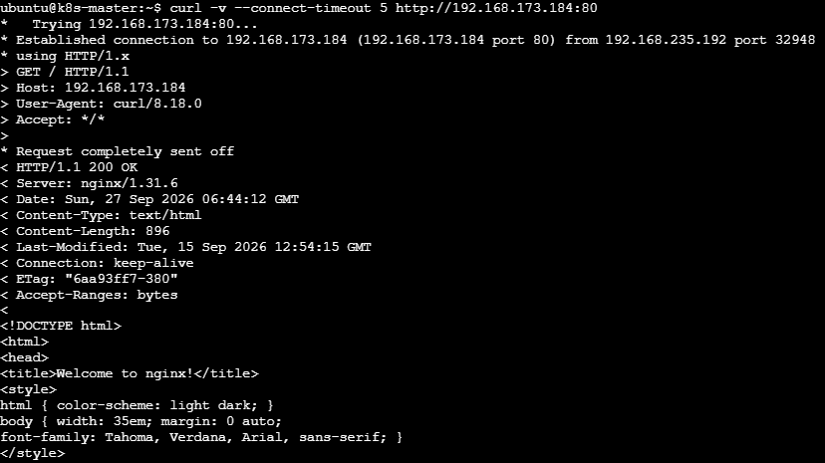
You should receive the Nginx welcome page.

Step 6: Verify the load-balancing backends
Run:
kubectl get endpoints nginx-nodeport -o wide
If you see all 3 Pod IPs, your NodePort Service is correctly connected to the 3 Nginx Pods.
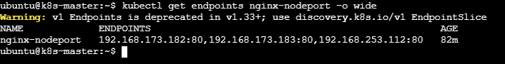
8. Delete a ReplicationController without affecting the running pods.

Step 1: Check your ReplicationControllers
Run on k8s-master:
kubectl get rc
You may see something like:
NAME DESIRED CURRENT READY
nginx-rc 3 3 3
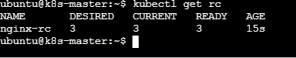

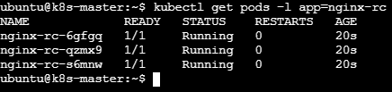

Step 2: Delete the ReplicationController but keep the above Pods
kubectl delete rc nginx-rc --cascade=orphan
Expected:
replicationcontroller "nginx-rc" deleted

Step 3: Verify the RC is deleted
kubectl get rc
The RC should no longer appear.
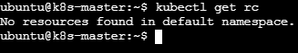

Step 4: Verify the Pods are still running
kubectl get pods -o wide

